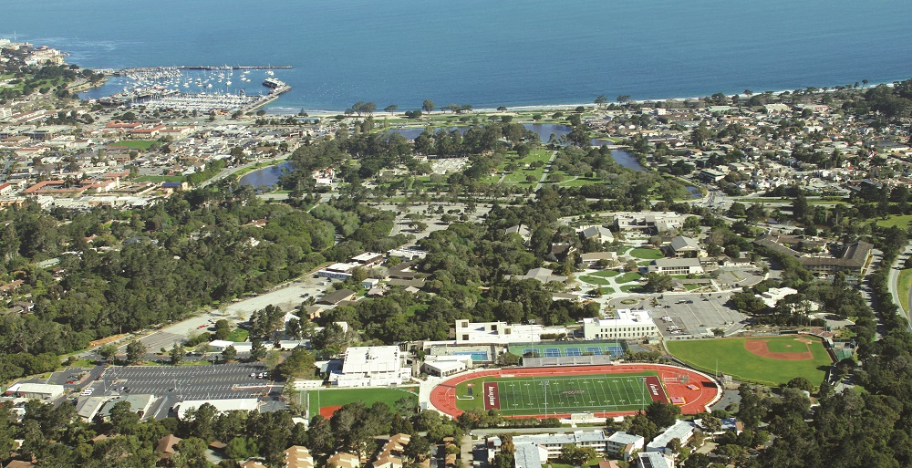

Not Club Volleyball Camp Registration Form

Participant's Name __________________________ Section: 1 (14+) or 2 (13-)

School___________________________________ Grade_______ Age_________

Home Address______________________________________________________

City_____________________________ State_______ Zip________________

Parents Name______________________________________________________

Parents Email______________________________________________________

Cell Phone (______) ______________ Cell Phone (______) _____________

In Case of Emergency Contact_________________________________________

Emergency Contact Phone Number_____________________________________

T-Shirt Size: (circle one) Youth: M L / Adult: S M L XL
DRESS: All players should wear appropriate attire.
INSURANCE: Participants must have medical insurance. Our insurance is supplemental.
WHAT YOU GET: Outstanding instruction, official camp T-shirt.
QUESTIONS: Phone MPC Volleyball Office at (831) 645-1347 or Cell Phone (83) 402-1257.

Section 1: 13 and under – Monday/Wednesday from 4:30-5:45pm Starts Feb. 12th.

Section 2: 14 and over – Monday/Wednesday from 5:45-7:00pm Starts Feb. 12th

-Location: Monterey Peninsula College Gym by parking lot C - Cost: $300
-Both boys and girls welcome
-Questions call Kit @ 831-645-1347 (This is a Fundraiser For Women's Volleyball)
-You can email form to kmoore@mpc.edu SUBJECT: not club
Registration also open first two weeks of camp
Make Checks Payable to: Kit Moore or MPC Volleyball

To register early
Office Use Only
PF:____A:____
P:___________

SEND YOUR REGISTRATION AND CHECK TO:
Care of: Kit Moore
980 Fremont St. Monterey Ca. 93940

