**Medical Insurance and Coding Specialist**

The Medical Insurance and Coding Specialist program prepares students for billing careers in a broad variety of health care settings.

**YOU WILL LEARN TO:**

* communicate with patients and members of the healthcare team
* understand and use medical language
* research and match appropriate codes to medical procedures and diagnoses
* understand concepts of medical necessity
* create and manage insurance claims
* follow up on insurance communications
* perform billing procedures
* perform medical office financial transactions and accounting procedures
* understand and follow laws and regulations as they apply to the medical office and health insurance

C:\Users\owner\AppData\Local\Microsoft\Windows\Temporary Internet Files\Content.IE5\3CX6IONB\MC900154362[1].wmf

**TWO OPTIONS:**

**1. Associate in Science Degree –** complete the required courses and general education courses and finish in about 2 years

**2. Certificate of Achievement –** complete all required courses and finish in 2-3 semesters

**NOTE:** It is not required to enroll in a program to take individual courses

C:\Users\owner\AppData\Local\Microsoft\Windows\Temporary Internet Files\Content.IE5\1AP0DW2X\MC900200423[1].wmf

**\*REQUIRED CORE COURSES:**

ANAT 5 Basic Human Anatomy and Physiology

CSIS 50 MS Office Applications

CSIS 50L MS Office Applications Lab

MEDA 100 Introduction to Health Careers

MEDA 101 Ethics, Law and IT Security

MEDA 105 Medical Terminology

MEDA 112 Medical Office Computer Applications

MEDA 113 Medical Procedure Coding

MEDA 114 Medical Insurance Management

MEDA 117 Medical Diagnostic Coding

MEDA 116 Medical Linguistics and Transcription

MEDA 118 Pharmacology and Human Diseases

ELECTIVES

*Specific course descriptions and program requirements are listed in the MPC catalog (www.mpc.edu)

After completing **the Medical Insurance and Coding Specialist** program, you can work in the billing department of a doctor’s office, a hospital, an outpatient clinic or wherever healthcare is administered. With experience, you may even be able to work from home as an independent contractor!

It’s easy to get started – visit [www.mpc.edu](http://www.mpc.edu) for registration information! Go to <http://www.mpc.edu/academics/academic-divisions/life-science/medical-assisting-meda> for information about our MEDA programs.

We are looking forward to meeting you!

MC900360988[1]**MONTEREY PENINSULA**

**COLLEGE**

*“Monterey Peninsula College is committed to foster student learning and success by providing excellence in instructional programs, facilities, and services to support the goals of students pursuing transfer, career, basic skills and life-long learning opportunities. Through these efforts MPC seeks to enhance the intellectual, cultural, and economic vitality of our diverse community.”*

For information about the enrollment procedure, contact:

**Counseling Department**

**Monterey Peninsula College**

**Phone: (831) 646-4020**

For more information about the Medical Insurance and Coding Specialist program, contact:

**Monika Bell, CMA**

**Medical Assisting**

**Program Coordinator**

**Life Science Division**

**Monterey Peninsula College**

**(831) 646-4135**

[**mbell@mpc.edu**](mailto:mbell@mpc.edu)

**Monterey Peninsula College**

**980 Fremont Street**

**Monterey, CA 93940-4799**

**Medical**

**Insurance and Coding Specialist**



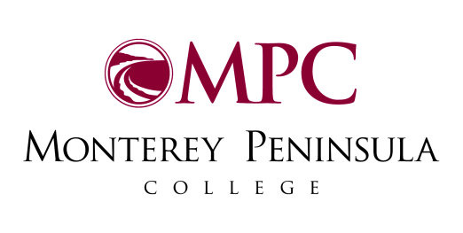

980 Fremont Street

Monterey, CA 93940-4799

[www.mpc.edu](http://www.mpc.edu)