Medical Office Administration

The Medical Office Administration program prepares students for administrative careers in a broad variety of health care settings.

YOU WILL LEARN TO:
- communicate with patients and members of the healthcare team
- greet and check in patients
- answer multiple phone lines
- schedule patients for appointments and procedures
- use medical office computer software
- identify common medications and their uses
- read, type, file and understand medical reports
- update and ensure completeness of medical records
- apply codes to medical procedures and diagnoses
- create and manage insurance claims
- follow up on insurance communications
- perform billing and accounting procedures
- process payroll
- understand and follow laws and regulations as they apply to the medical office

TWO OPTIONS:
1. Associate in Science Degree – complete all required courses and general education courses and finish in about 2 years
2. Certificate of Achievement – complete all required courses and finish in 3 semesters
NOTE: It is not required to enroll in a program to take individual courses

*REQUIRED CORE COURSES:
ANAT 5 Basic Human Anatomy and Physiology
BUSI 120A Basic Accounting
CSIS 50 MS Office Applications
CSIS 50L MS Office Applications Lab
MEDA 100 Introduction to Health Careers
MEDA 101 Ethics, Law and IT Security
MEDA 105 Medical Terminology
MEDA 110 Medical Office Management
MEDA 112 Medical Office Computer Applications
MEDA 113 Medical Procedure Coding
MEDA 114 Medical Insurance Management
MEDA 117 Medical Diagnostic Coding
MEDA 116 Medical Linguistics and Transcription
MEDA 118 Pharmacology and Human Diseases
ELECTIVES
*Specific course descriptions and program requirements available in the MPC catalog (www.mpc.edu)

After completing the Medical Office Administration program, you can choose from a variety of job options in the medical field. You can work in a doctor’s office, a hospital, an outpatient clinic or wherever healthcare is administered.

The training and knowledge you gain in the Medical Office Administration program will make you a valuable employee. It’s a great way to enter the healthcare field or switch to a second career, especially with prior customer service experience!

It’s easy to get started – visit www.mpc.edu for registration information! Go to http://www.mpc.edu/academics/academic-divisions/life-science/medical-assisting-meda for information about our MEDA programs.



MONTEREY PENINSULA
COLLEGE

“Monterey Peninsula College is committed to foster student learning and success by providing excellence in instructional programs, facilities, and services to support the goals of students pursuing transfer, career, basic skills and life-long learning opportunities. Through these efforts MPC seeks to enhance the intellectual, cultural, and economic vitality of our diverse community.”

For information about the enrollment procedure, contact:

Counseling Department
Monterey Peninsula College
Phone: (831) 646-4020

For more information about the Medical Office Administration program, contact:

Monika Bell, CMA
Medical Assisting
Program Coordinator
Life Science Division
Monterey Peninsula College
(831) 646-4135
mbell@mpc.edu

Monterey Peninsula College
980 Fremont Street
Monterey, CA 93940-4799

Medical
Office Administration

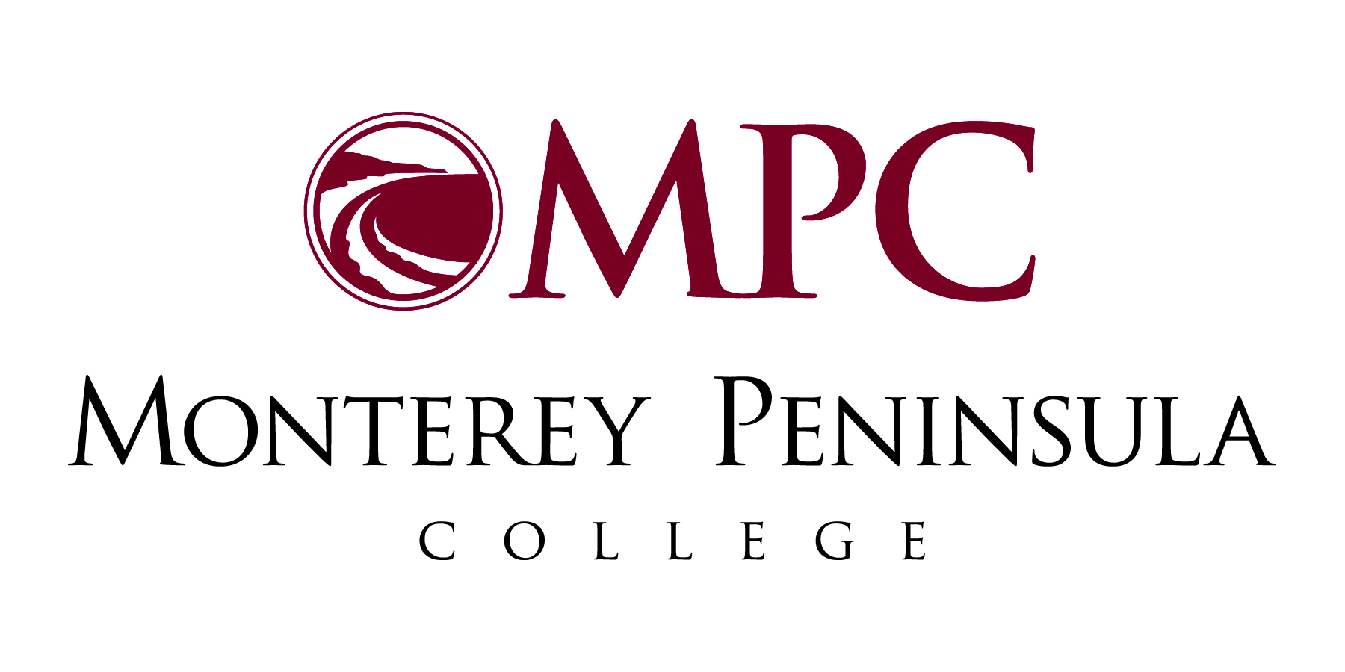

980 Fremont Street
Monterey, CA 93940-4799
www.mpc.edu

