**Two In A Row – Monterey Peninsula College Football Alums Take Part in NFL Combines.**

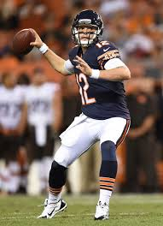

**2014 NFL Combine – QB Davis Fales – Drafted Chicago Bears**

*“Coach Rasmussen runs the MPC Football Program like a Division 1 program. Lobo Football prepares you for the next level.”*

David Fales

**2015 NFL Combine – OL Terry Poole – San Diego State**

*“I would not be where I am today without Lobo Football. MPC helped me grow up in all areas of my life. I have earned my degree from San Diego State; and now have an opportunity to fulfill my dream of playing in the NFL”.*

Terry Poole

