**PRE-NURSING STUDENTS**

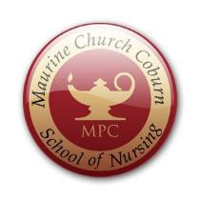

# Maurine Church Coburn School of Nursing offers:

**NURS 150 1.5 UNITS**

NURSING PROGRAM READINESS

* *What to get a sense of what being in the Nursing Program is like?*
* *Want to find out if a Nursing career is for you?*
* *Want to have more preparation for the TEAS test?*
* *Want to learn strategies to enhance admission into the Nursing Program?*
* *Want to get a head start?*

**Then this class is for you!**

*(there are no pre-requisites for this course)*

# Register online

*Questions?? Call the School of Nursing at 646-4258*

*Or see the nursing program academic counselor 646-4020*