**CERT NEWS LETTER**

**December 2014**

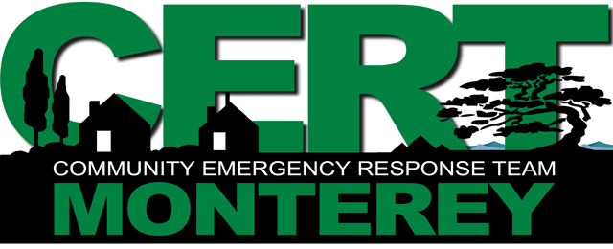

**CERT Medical Protective Equipment (PPE), Emergency Disaster Supplies, New CERT Class for new members, CERT Quarterly Drill in January, Contact Your Team Leader**

**CERT Medical Personal Protective Equipment (PPE):**

* **Rubber Gloves**
* **Eye protection**
* **N-95 rated surgical mask**
* **CERT issued helmet & vest**

**REMEMBER:** This is your **minimum** protection. Caution is your best defense. Always be looking up, down and side-to-side. Avoid stepping on or kneeling in any fluids. Be careful where you are placing your hands. Avoid touching blood or other bodily fluids whenever possible. When your medical gloves become contaminated, replace them as soon as possible. If a patient is coughing, place a mask on them to reduce potential exposures. ALWAYS carry extra protective equipment. Have a minimum of 5 extra pairs of rubber medical gloves and 3 N-95 surgical rated masks with you whenever operating as a CERT. Wash your hands frequently if you’ve been working around injured persons. **Below: CERT members in medical PPE**

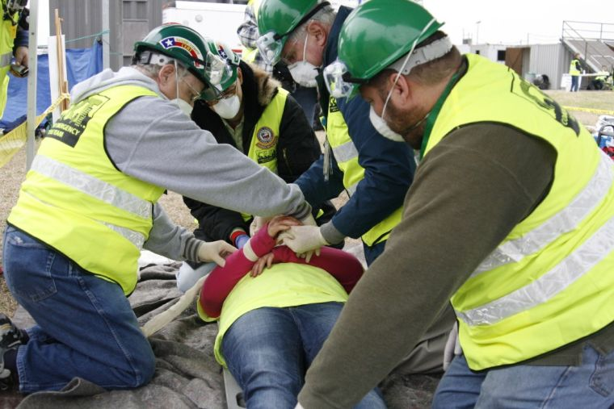

**EMERGENCY DISASTER SUPPLIES:** CERT begins at home! Remember to keep and maintain your home disaster supplies. Keep as much as you reasonably can, but a 7 day supply of food and water should be the minimum you keep. A 30 day supply is ideal. REMEMBER not to forget the pets! They are important members of the family. Keep portable cages with your emergency pet supplies as evacuation centers typically do NOT allow uncaged pets inside the center.

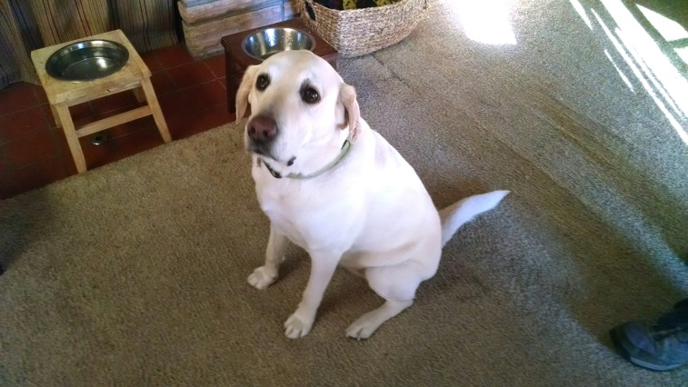

**Don’t forget about me….!**

For a list of items to keep for your disaster supplies, consult the link below. Have a family rendezvous point in case you cannot get home.

<http://www.fema.gov/media-library-data/1390846764394-dc08e309debe561d866b05ac84daf1ee/checklist_2014.pdf>

**NEW CERT CLASS**: March 2015

Monterey CERT has confirmed dates for the next CERT training for new students.  This will be our weeknight series, taught over seven consecutive Thursday nights.  Location will be the Monterey Emergency Operations Center (EOC) in the parking lot to the left of fire station #1 on Pacific Street.  Class time each day will be **6:30-9:30 p.m.**  **Student should plan on attending all 7 nights**.  
**Class dates**will be:  
March 5, 12, 19, 26  
April 2, 9, 16   
Persons wishing to enroll may send an email to:  montereycert@hotmail.com  Please include the following information:  
Full name  
Physical and mailing address  
e-mail address most commonly used  
Cell and home phone numbers  
  
Registering students will receive an e-mail confirmation.  Persons without e-mail may leave a phone message at:  (831) 646-3416.

*The****Community Emergency Response Team (CERT)****Program educates people about disaster preparedness for hazards that may impact their area and trains them in basic disaster response skills, such as fire safety, light search and rescue, team organization, and disaster medical operations. Using the training learned in the classroom and during exercises, CERT members can assist others in their neighborhood or workplace following an event when professional responders are not immediately available to help.*  
  
**CERT Quarterly Drill in January:** Our Monterey CERT program will be holding a **Search & Rescue drill for Coastal operations**. It is a very real possibility that we can provide enormous assistance to search crews looking for someone who has been swept out to sea. **By posting teams in safe locations** along the shoreline, CERT can provide a large number of “Coastal Spotters”, who can coordinate with our radio system to locate a victim in the water.

**Drill Date**: To be determined in January or early February 2015

**Staging Location**: Lover’s Point next to the Beach House Restaurant, 620 Ocean View Blvd., Pacific Grove

**CONTACT YOUR TEAM LEADER:** If you have not already done so, contact your team leader and meet them at your neighborhood CERT container. Make sure you know how to find the container and are familiar with the inventory.

**REMEMBER:** After an emergency such as an earthquake, storm or other potential disaster when all forms of communication are absent, when the power is out and telephones and cell phones don’t work, secure your family, immediate neighbors and then, if you are able, report to your neighborhood CERT container. Using our radio system, CERT is the primary eyes and ears to the City on what’s happening in the neighborhoods. We will form teams and proceed into the neighborhoods to *“DO THE MOST GOOD FOR THE MOST PEOPLE …..”* CERT provides an excellent video at this link: <http://www.youtube.com/watch?v=KwV3e1XfIF0>

**CERT TEAM LEADER LIST: CONA=**Casanova Oak Knoll**, Crml=**Carmel**, DMB=**Del Monte Beach**, FH=**Foothill**, MV=**Monte Vista**, NM=**New Monterey**, OG=Oak Grove, OT=**Old Town, **PG=**Pacific Grove**, S3=**Station 3**, SL=**Skyline

|  |  |  |  |
| --- | --- | --- | --- |
| CONA | Ruccello | Richard | [rruccello@aol.com](mailto:rruccello@aol.com) |
| CONA | Brassfield | Michael | [monami@redshift.com](mailto:monami@redshift.com) |
| Crml | Larrew | Lee | [lee@carmelcalifornia.org](mailto:lee@carmelcalifornia.org) |
| DMB | Swisher | Gerald | [concretescarecrow@gmail.com](mailto:concretescarecrow@gmail.com) |
| DMB | Brownlee | Sean | sean@globalfms.com |
| FH | Foss | Chuck | [chuckfoss@comcast.net](mailto:chuckfoss@comcast.net) |
| FH | Mendenhall | Bruce | [bmende88@comcast.net](mailto:bmende88@comcast.net) |
| FH | Rygg | Ronald | ronnr7@aol.com |
| MV | Alameda | Lisa | [ken.alameda@comcast.net](mailto:ken.alameda@comcast.net) |
| NM | Rizzo | Maya | tangorizz@aol.com |
| NM | Rizzo | Gene | [tangorizz@aol.com](mailto:tangorizz@aol.com) |
| OG | Dawson | Mike | [mike@dawsonmonterey.com](mailto:mike@dawsonmonterey.com) |
| OG | Whitney | Lee | [lwhitney306@gmail.com](mailto:lwhitney306@gmail.com) |
| OT | Netzorg | Greg | [thezorgs1@comcast.net](mailto:thezorgs1@comcast.net) |
| OT | Rasmussen | Thor | [thor@mbay.net](mailto:thor@mbay.net) |
| OT | Mcfaddan | Tim | [mcfaddan@gmail.com](mailto:mcfaddan@gmail.com) |
| PG | Oder | Broeck | [bnoder@gmail.com](mailto:bnoder@gmail.com) |
| PG | Zamzow | Heidi | [hzamzow@aol.com](mailto:hzamzow@aol.com) |
| S3 | Blackstone | Sarah | [sarahblack@aol.com](mailto:sarahblack@aol.com) |
| S3 | Pressman | Harvey | [presstoe@aol.com](mailto:presstoe@aol.com) |
| SL | Duke | Dennis | [dduke01@sbcglobal.net](mailto:dduke01@sbcglobal.net) |
| SL | Kastros | Demetrius | [demekastros@msn.com](mailto:demekastros@msn.com) |
| SL | Pasquinelli | Art | pasquin@redshift.com |

***“Doing the most good for the most people …….”***